Tanzania

## Freedom House political status

The data set shows the Freedom House political scores and status of the country each year.

## # A tibble: 19 x 5  
## country iso3c date mean status   
## <chr> <chr> <dbl> <dbl> <chr>   
## 1 Tanzania TZA 1996 5 Partly Free  
## 2 Tanzania TZA 1998 4.5 Partly Free  
## 3 Tanzania TZA 2000 4 Partly Free  
## 4 Tanzania TZA 2002 3.5 Partly Free  
## 5 Tanzania TZA 2003 3.5 Partly Free  
## 6 Tanzania TZA 2004 3.5 Partly Free  
## 7 Tanzania TZA 2005 3.5 Partly Free  
## 8 Tanzania TZA 2006 3.5 Partly Free  
## 9 Tanzania TZA 2007 3.5 Partly Free  
## 10 Tanzania TZA 2008 3.5 Partly Free  
## 11 Tanzania TZA 2009 3.5 Partly Free  
## 12 Tanzania TZA 2010 3 Partly Free  
## 13 Tanzania TZA 2011 3 Partly Free  
## 14 Tanzania TZA 2012 3 Partly Free  
## 15 Tanzania TZA 2013 3 Partly Free  
## 16 Tanzania TZA 2014 3 Partly Free  
## 17 Tanzania TZA 2015 3.5 Partly Free  
## 18 Tanzania TZA 2016 3.5 Partly Free  
## 19 Tanzania TZA 2017 4 Partly Free

## Freedom House classification of political change

The data set shows the GDP growth and the ecomic growth classification of the country each year.

## # A tibble: 19 x 4  
## country iso3c date politicalChangeFH  
## <chr> <chr> <dbl> <chr>   
## 1 Tanzania TZA 1996 no change   
## 2 Tanzania TZA 1998 democratization   
## 3 Tanzania TZA 2000 no change   
## 4 Tanzania TZA 2002 democratization   
## 5 Tanzania TZA 2003 no change   
## 6 Tanzania TZA 2004 no change   
## 7 Tanzania TZA 2005 no change   
## 8 Tanzania TZA 2006 no change   
## 9 Tanzania TZA 2007 no change   
## 10 Tanzania TZA 2008 no change   
## 11 Tanzania TZA 2009 no change   
## 12 Tanzania TZA 2010 democratization   
## 13 Tanzania TZA 2011 no change   
## 14 Tanzania TZA 2012 no change   
## 15 Tanzania TZA 2013 no change   
## 16 Tanzania TZA 2014 no change   
## 17 Tanzania TZA 2015 autocratization   
## 18 Tanzania TZA 2016 no change   
## 19 Tanzania TZA 2017 autocratization

## Freedom House score trend

The plot shows the Freedom House scores trend of the country.

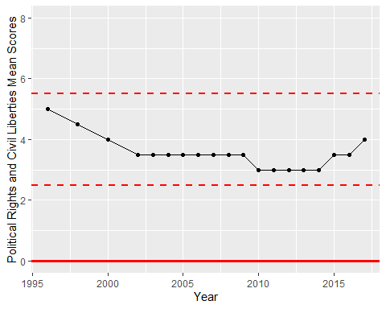

Freedom House Score Trend